Week-03-Decision making and branching -if.if

else and nested if…else..if….else if and switch ….case

Week-03-01-practice Session-coding

Reg No;241801289

NAME;TAMILSELVAN.K

Q1}

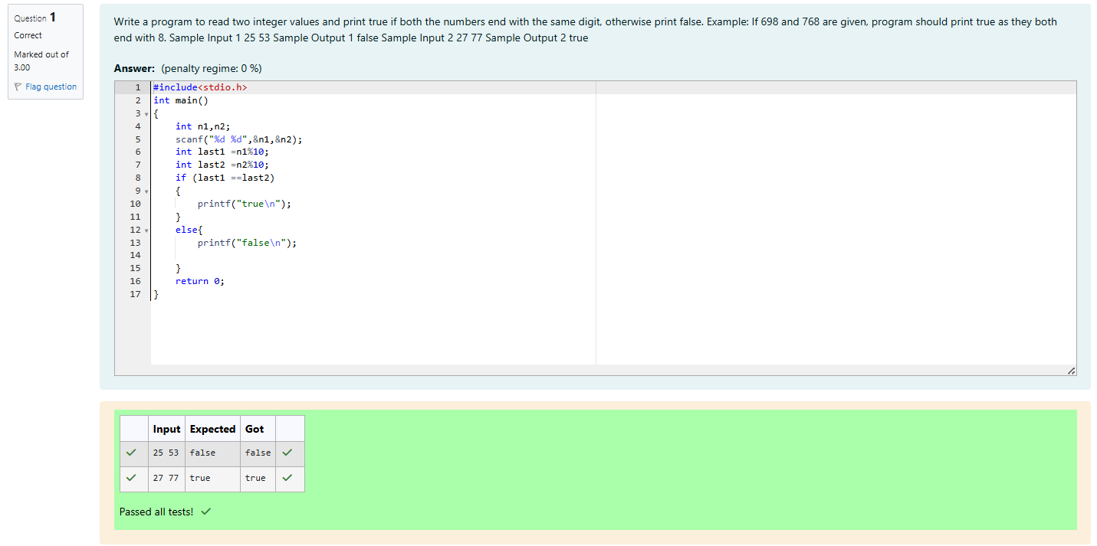

Week-03-01-practice Session-coding

Reg No;241801289

NAME;TAMILSELVAN.K

Q2}

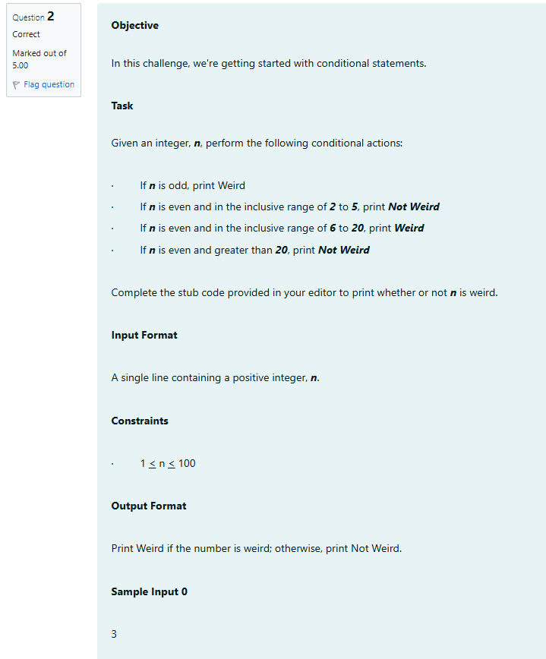

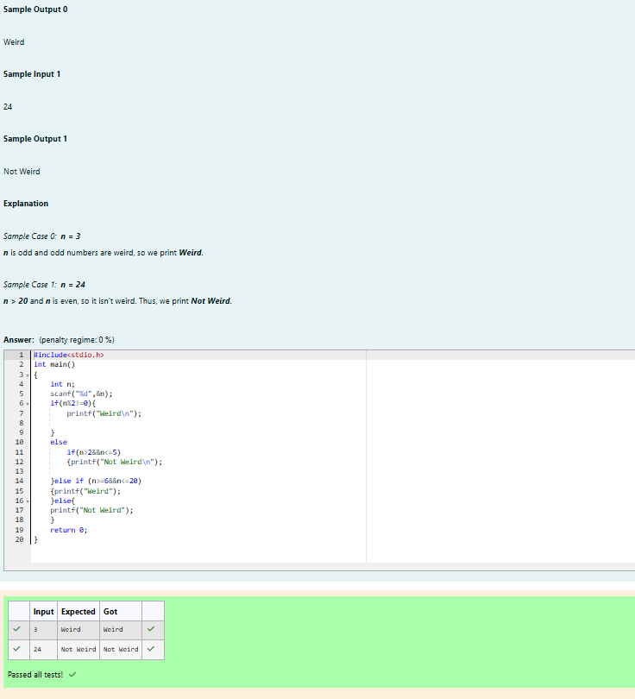

Week-03-01-practice Session-coding

Reg No;241801289

NAME;TAMILSELVAN.K

Q3}

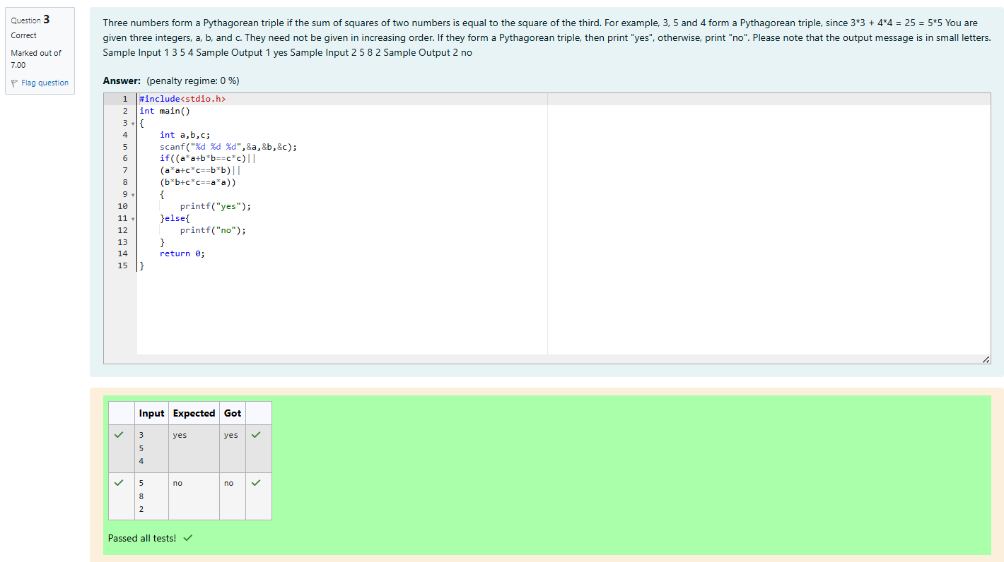

Week-03-02-practice Session-coding

Reg No;241801289

NAME;TAMILSELVAN.K

Q1}

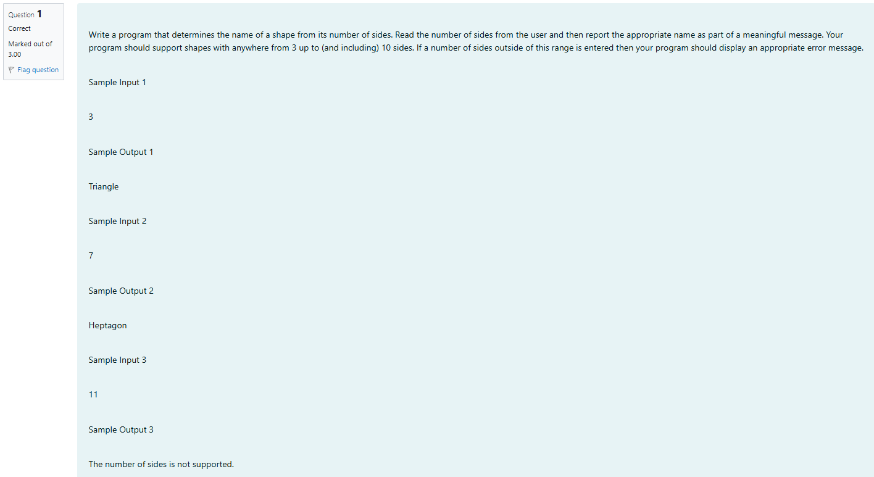

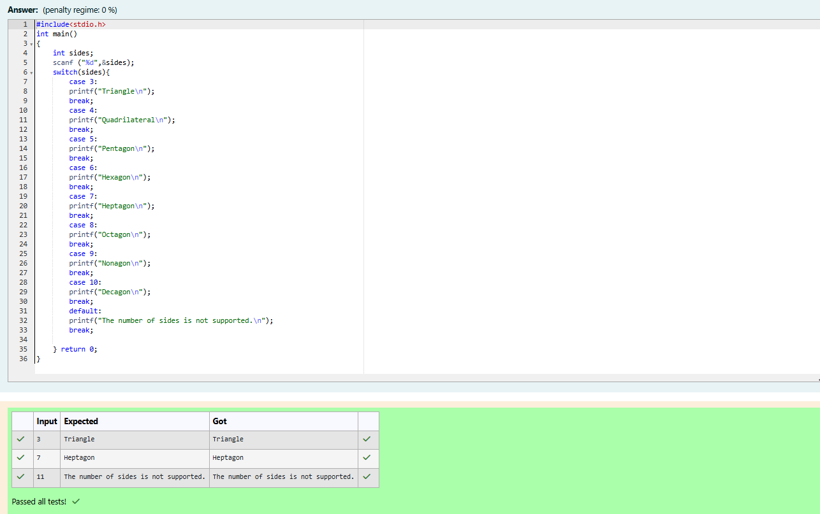

Week-03-02-practice Session-coding

Reg No;241801289

NAME;TAMILSELVAN.K

Q2}

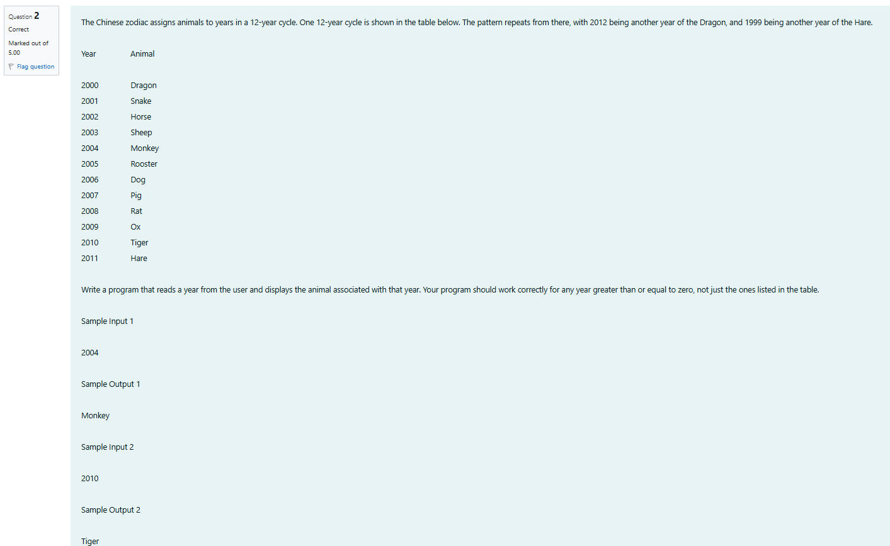

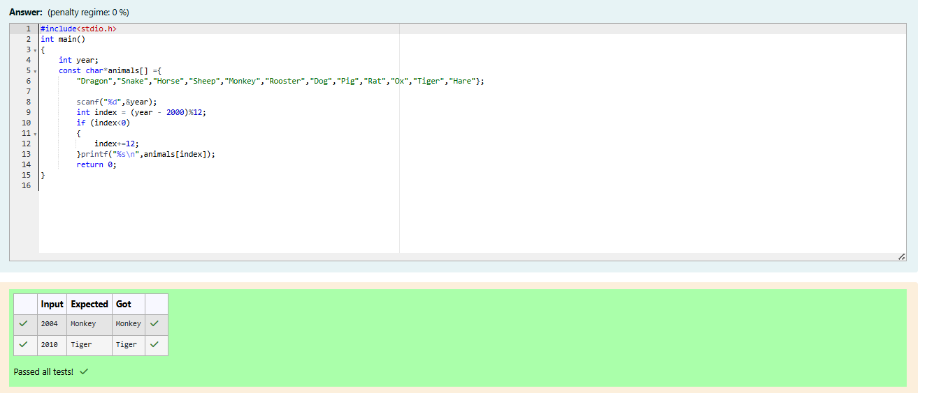

Week-03-02-practice Session-coding

Reg No;241801289

NAME;TAMILSELVAN.K

Q3}

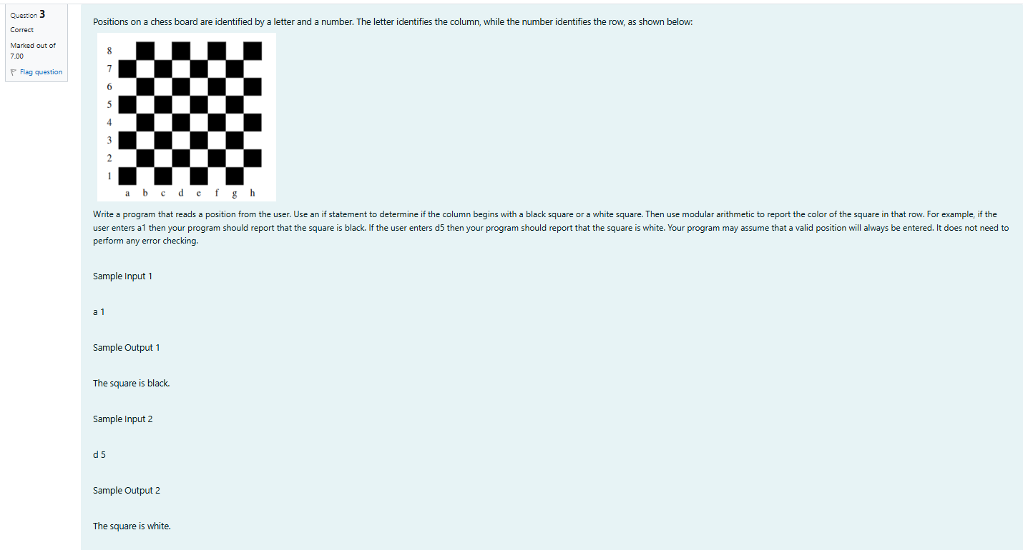

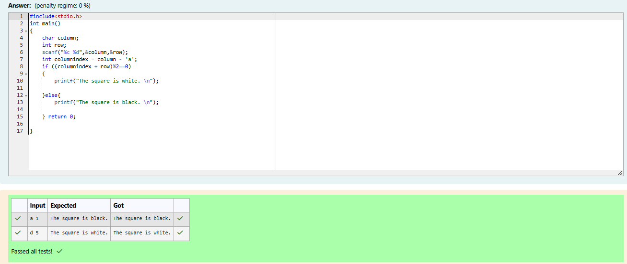

Week-03-03-practice Session-coding

Reg No;241801289

NAME;TAMILSELVAN.K

Q1}

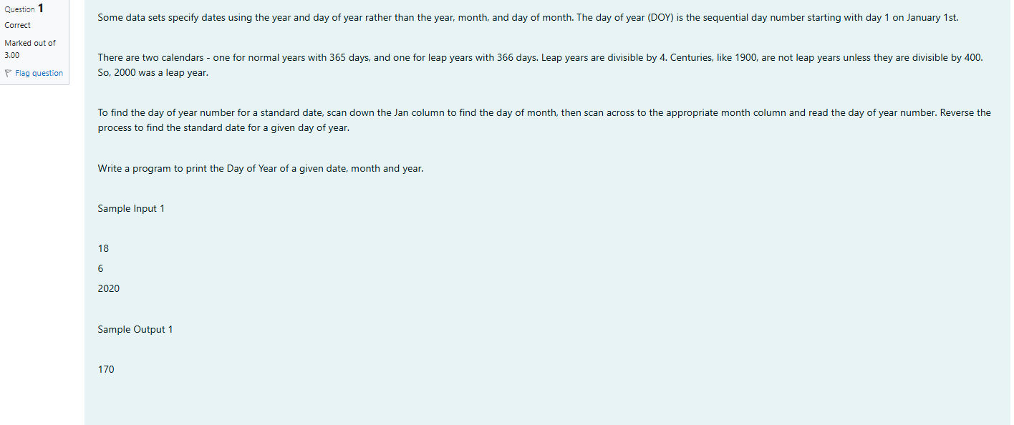

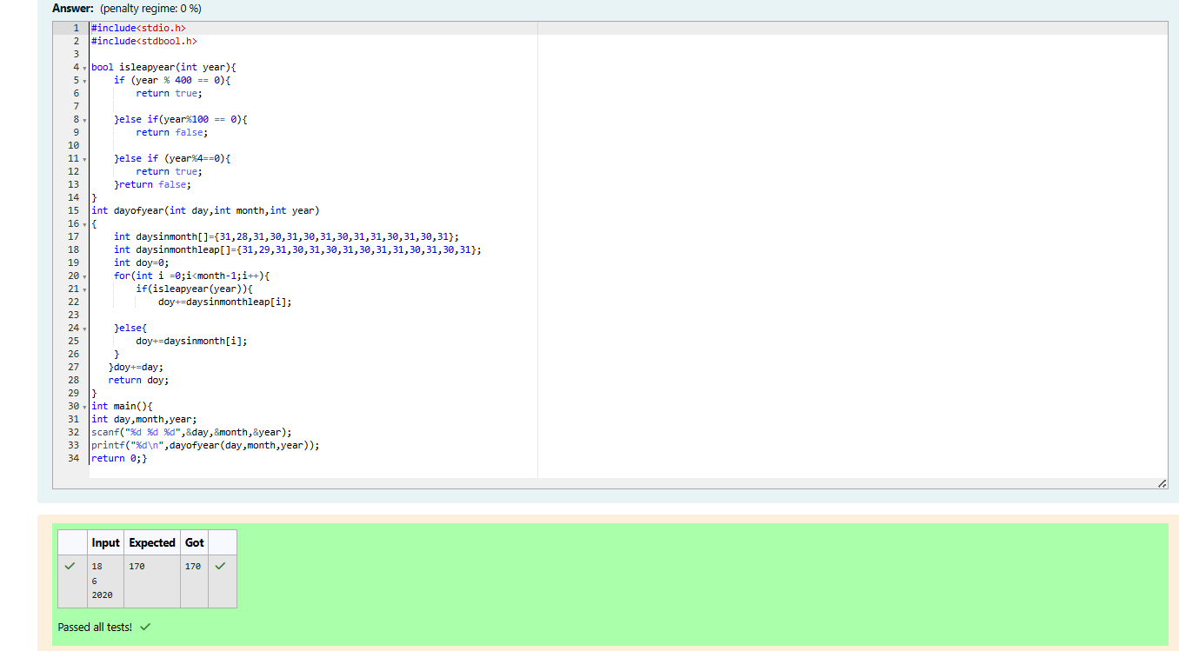

Week-03-03-practice Session-coding

Reg No;241801289

NAME;TAMILSELVAN.K

Q2}

